SMART HOUSE

ARDUINO UNO

BLUETOOTH MODULE

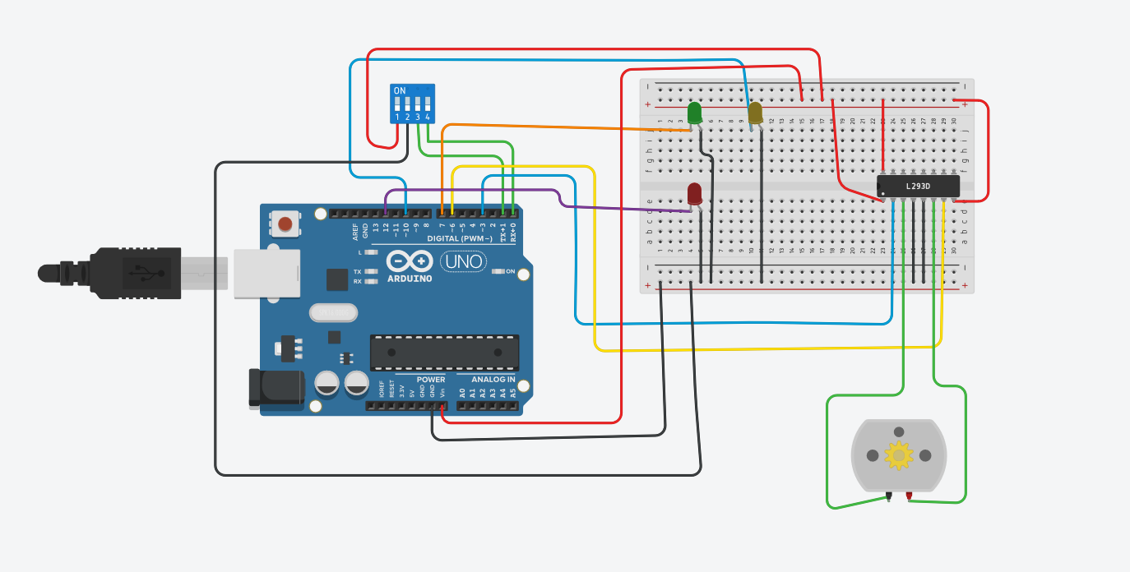
DC MOTOR

GARAGE DOOR

LIGHTS

AC

HEATER

BREADBOARD

BATTERY

